Scans: https://photos.app.goo.gl/CgsgSjBWL838CiQs8
Thursday, July 25, 1990
2:35AM

Some very important information was not released in the November 1961 paper on falling bodies.

Why wasn't all the information released? you might ask.

As my memory goes back 29 yrs.; I might ask myself the same question. However, in 1961 my mind set was still hooked into the system of physics and the process of higher education, which is better known as "the old boy system".

Under the rules of the game, a researcher was to make one statement and support that statement with the evidence provided by his or her work. Then you were to wait a minimum of l year and make the next statement; once more, of course backed by evidence.

In the release of the 1961 paper on falling bodies, I had already broken the rules; I had made three(3) statements. These statements, backed by evidence, was not accepted by the "priest" of the old boy system, so the normal process of reproducing the test was not taken into consideration.

With complete rejection of the November 1961 paper, I never had the opportunity to make any further statements.

Today, I will make those statements. Should these statements be acceptable to you the reader, that's o.K.

Should the following statements not be acceptable to you the reader, that's O.K. too.
I no longer have the desire or time to appease the scientific community or any one else. In the closing days of my life, I refuse to argue with any one at any time, over any subject.

Instead, I urge you, as I have urged people more than 29 yrs. Ago.

MAKE YOUR OWN TEST ON FALLING BODIES.

Should you wish to discuss falling bodies with me, I will be more than willing to do so. However, my first question to you will be; FROM WHAT POINT OF REFERENCE DO WE SPEAK?

Should you, yourself, not perform test on falling bodies, then what is there to speak of?

A fundamental law of physics states that; falling bodies accelerate at the same rate!

This law is based on the hypothetical work by Galileo Galilei (1564-1642) This hypothetical work was presented for the sole purpose of contradicting the church held belief that was postulated by Aristotle in regards to falling bodies.

Should you wish to do a small amount of research, study the life and work of Galileo.

You are in for some shocking surprises! Should you merely open your encyclopedia you will find a typical Galileo test. Which the great learned ones (Scientific Community) hold dearly too!

Should the full professors get off of their fat buns and run that simple test, they would begin to see how nonsensical their teachings are in

regards to falling bodies. A drawing of Galileo's test can be seen in figure l. this is a legitimate and accepted by this Scientific community.

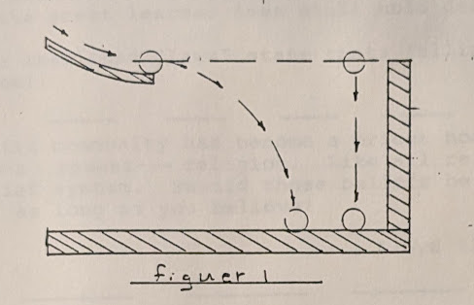

With Galileo's test, using a 4ft. track on a 6ft. drop, it is claimed that body A and B strike the impact area at the same time, increasing the track and the over all drop length clearly shows that test and statement to be untrue. Body B strikes the impact area first at all times!!!

Galileo worked out the math in regards to acceleration rates, this simply says that a free falling body will accelerate at a rate of 32ft. per second/second. This is accepted today by the Scientific Community as "law"!

In other words, at the end of l second of free fall, a body will have a velocity of 32ft. per second.

In the following second the body will have gained a velocity of 32ft. So' at the end of the second, second the body has a velocity of 64ft. per second. At the end of the 3rd second, the body has once more gained 32ft. and therefor, has a 3rd. second velocity of 96 feet per second, at the end of each second, merely add 32ft. to the previous Sum.

I have found this acceleration rate to be relatively correct! That is, as long as the drop is 1000ft. or less!

After 1000ft of free fall, many things begin to happen. A hardened steel ball will no longer gain a velocity of 32ft. per second. Therefore, I have made the statement that: a body with a high value of permeability and a high value of retentivity will have a drastic decrease in acceleration rates after a 1000 foot free fall!!

Under the theory of terminal velocity the free falling bodies will achieve a maximum velocity and forever more remain at that velocity. This allows the great learned ones to explain why a comet, planet, solar system or galaxies retain a given velocity.

Within this "law" we can quickly see a theory to explain theories that can explain yet other theories which can't be explained either.

At the end of a long line of theories the great learned ones make a "law". Even when the basic theories to that chain of events is proven incorrect; the great learned ones still hold dearly to their "law"!

One of those cherished "laws" state that; falling bodies accelerate at the same rate!!

The scientific community has become a priest hood, they are priest in the earths newest--- religion. Like all religions; there must exist a belief system. Should those beliefs be true or not are irrelevant, as long as you believe!

Lloyd Zirbes 1986

Figure l is considered a legitimate test. This illustration is used in physics classes today.

This illustration is supposed to show that a horizontal falling body obtains the same velocity as a body falling perpendicular with the earth. Physicists (full professors) proclaim to their students that: a body released on a slide, as indicated in figure l, will strike the impact area at the same instant as a body that is released at the same instant that the horizontally moving body leaves the slide. this holds true they proclaim; they speak with authority and confidence, in the same manner that a priest speaks to their sheep.

Lets now look to figure 2 and quickly analyze what the illustration, very clearly, shows.

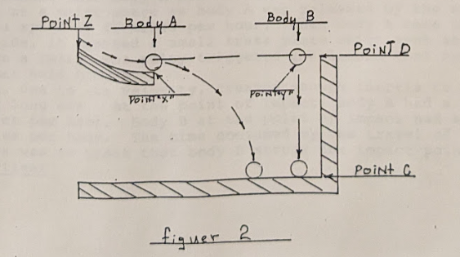

Should a person decide to make a study of falling bodies there emerges three imperative factors.
Those major factors are; (1) the distance that the body has or will fall. (2) velocity- what velocity will the body in question achieve? (3) at any given point what will be the acceleration of the body.

As we look at body A, in figure 2 we can quickly see that body A is under the influence of two dynamic vectors.

At any given instance, body A has circular vector and a horizon movement (vector 2). Body "B" at the very same instance, is at rest!

This in itself dictates that the illustration in figure l and figure 2 to be invalid !! The time required for body A to strike the impact area (point C) is not determined by distance! The time required for body A (point X) to strike the impact point (point C) is determined by the velocity of body A as it leaves point X. The perpendicular distance body A has to fall (point D/C) becomes a very minor factor.

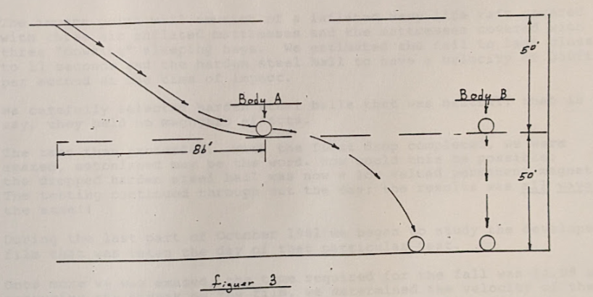In figure 3, you can see a diagram of a slide arrangement that was set up and used in some basic test.

We estimated that body A had accelerated to a velocity of 674ft. per second at a point where as body A was released by the slide, this is about a speed of 46 miles per hour. When body A came to the end of the slide, it crossed a small brass plate which sent an electrical flow to a relay, the relay triggered a solenoid that opened the drop box that held body B.

Body A, due to its velocity, created enough inertia to carry it into a very long ark. At the point of impact, body A had a velocity of 92 miles per hour. Body B at the point of impact had a velocity of 45 miles per hour. The time consumed by the travel of body A, through the arc was so great that body B struck the impact point 1st ! Every-time!

At no time did the stardust team consider this to be a valid test.

A person can (as we have done) manipulate the drop distance and the slide dimensions so as to present a situation where as body A and body B strike the impact area at the same instance. However, this can not be considered valid under any circumstances!!

It was September 196l, after a cool night, the morning warmth from the sun felt good. The Star Dust team finished breakfast and re-checked the days schedule, it was now 6: 30AM.

We had previously noticed that some of the hardened steel balls used in the 2000 foot drop, had mysteriously developed mild magnetic fields.

Today we would drop hardened steel balls from 2000ft; the impact point would be cushioned to provide a relatively soft landing.

The impact point will consist of an inflated Navy life raft covered with three air inflated mattresses and the mattresses covered with three "downing" sleeping bags. We estimated the fall to last close to 11 seconds and the hardened steel ball to have a velocity of 350ft. per second at the time of impact.

We carefully selected hardened steel balls that were neutral, that is to say, they held no magnetic effects.

The test then proceeded. With the first drop completed, we were amazed, astonished may be the word. How could this be possible: the dropped harden steel ball was now a low valued permanent magnet!! The testing continued through out the day; the results was ways the same!!

During the last part of October 1961 we began to study the developed film that was taken the day of that particular test.

Once more we were amazed, the time required for the fall was 14.08 sec. measuring the streak on the film, we determined the velocity of the ball at the time of impact was 290ft. per sec.!! The 32ft. per sec. second law as used and believed by the scientific community was grossly in error when applied to a free falling body of hardened steel.

The nights were getting longer and colder, the 12 man army tent that we used did not offer
to much protection from the weather. We decided to run one more series of tests and then pack up and head for the warmth of our own homes.

We would now drop a l0lb. harden steel ball simultaneously with a 8 oz. harden steel ball.
---------------------------------------------------------------------------------------------------------------
Note- In this series of testswe also used a 1 lb. hardened steel ball with a 1 oz. hardened steel ball, the results were almost identical.

At the end of 1000 ft. of fall, we found the smaller ball was slightly ahead of the larger ball, we figured this was due to air resistance. See fig. 4

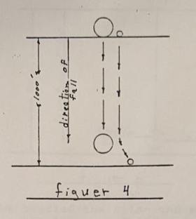

At the end of a 1500 foot fall we’ve seen a different situation, see fig. 5

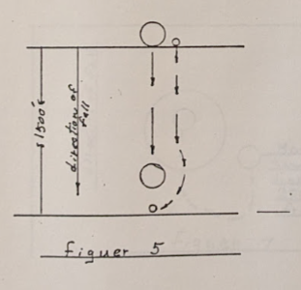

At a fall distance of 1500ft. the smaller ball would move beneath the larger ball-at the time we could not come up with an acceptable answer as to why this might be.
At the impact point, after a 2000 foot free fall, we found yet another position of the smaller ball, this can be seen in fig. 6

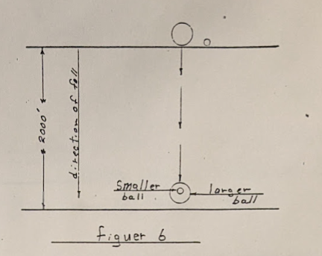

With excitement we studied the film- the smaller ball was apparently beginning to orbit the larger body!!!

We spent over a week working on this series of tests. Over one hundred drops were made in this series. The balls at the drop box (s) were placed in many different positions. The results was always the picture that can be seen in fig. 7

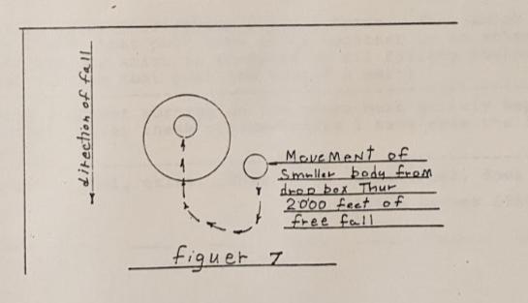

Figure 8 shows the data of a hardened Steel body after a 2000 foot free fall.

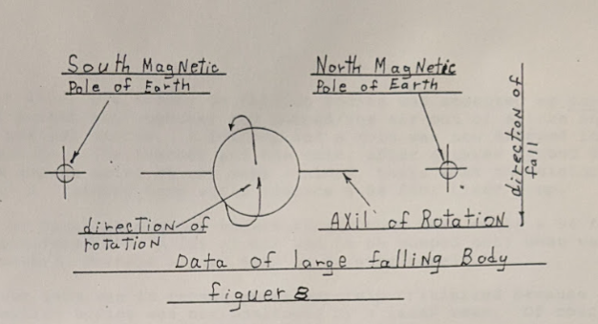

Although not conclusive; we stuck out our necks and stated; when a larger body is simultaneously dropped with a much smaller body: the smaller body obtains an orbit around the larger body.

It required many years of work and thought to develop equations and theories to explain this phenomenon.

This same phenomenon is readily apparent in particle physics and the cosmos!

There exist no weak or strong nuclear force. That which exist is magnetic fields that pull each other together in an attempt to unify and gravity which is produced by all falling bodies and offers a repulsive force that push the bodies a part!

---------------------------------------------------------------------------------------------------------------
A research engineer working on the bench must quickly separate fact from fiction, under these circumstances I have made the fallowing statement.
---------------------------------------------------------------------------------------------------------------
That which is real, exists. That which is not real, does not exist!
Lloyd Zirbes 1985

In the year 1650, the theory on falling bodies was accepted as Law. A group of priest got together and pumped/the air out of a tube and created a partial vacuum. A feather and a coin was now dropped in the vacuum tube. The feather and the coin, after a three second drop, struck the impact point at the same instant, thats what the history books say. A 3/second drop would require a 94 foot clear drop.

The tower of Pisa was a major undertaking. What then would a 94 foot tube be considered as? A lot of air had to be pumped out; what was used for power? Perhaps a wind mill or a water wheel?

The stardust team was in recent years severely critisized because our test on falling bodies was not monitored by a lazer beam. Of course lazer beams simply did not exist in 1960 and 1961.

With the same thought in mind, where did Galileo and his followers in 1650 get their lazer beam from? The only system of monitoring was the naked eye!!

